Assignment – 3

1.

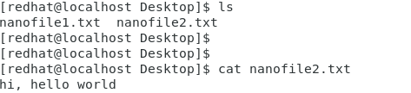

2.

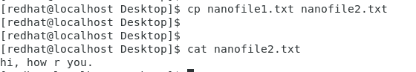

3.



4.

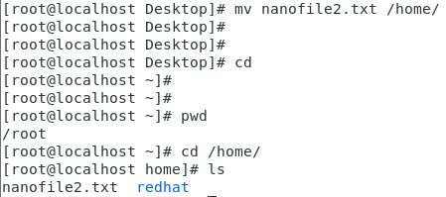

5.

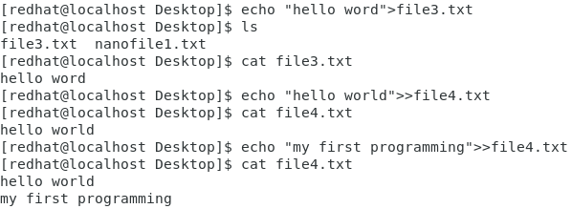

“>“: Overwrites the existing file, or creates a file if the file of the mentioned name is not present in the directory.

“>>“: Appends the existing file, or creates a file if the file of the mentioned name is not present in the directory.

6.

